Location  Sullivan Brothers Iowa Veterans Museum & Grout Museum  503 South St  Waterloo, IA 50701  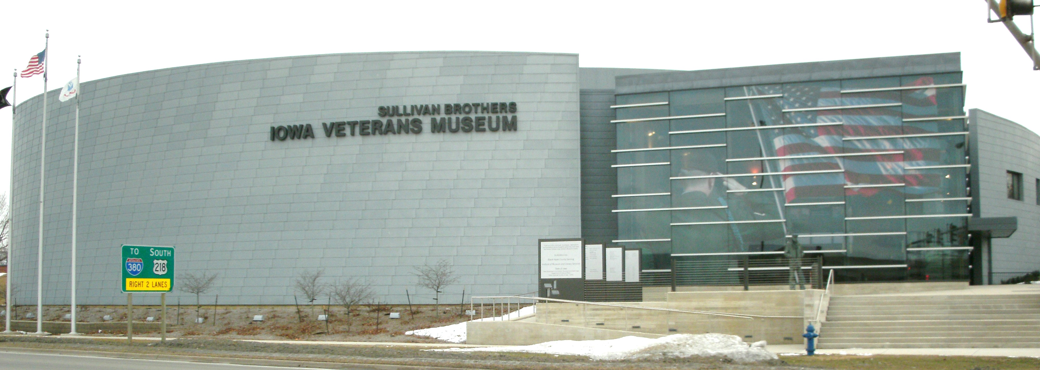  Hotel Information  Block of rooms are reserved at Courtyard by Marriot  250 Westfield Ave  Waterloo, IA 50701  319.233.5531  Room Rate $109/night using code Midwest SGNA  Continuing Education Hours:  6.0 Contact Hours for continuing education have been approved through the MSGNA, Provider #182, which is an approved provider of continuing education in nursing by the Iowa Board of Nursing. Participants must attend the entire conference for continuing education award.  GI specific contact hours have been applied for through the American Board of Certification for Gastroenterology Nurse (ABCGN) for purposes of recertification by contact hours through the ABCGN. |  | Kalyn Putz  5390 11th Avenue  Dysart, IA 52224 |  |  | GI TAILGATE  MSGNA FALL REGIONAL CONFERENCE  Saturday, September 28, 2019  Hosted By: Kristin Carpenter, Jo Sienknecht, Holly Dorn, Kalyn Putz, Brooke Miller  Purpose: MSGNA Conferences Provide Updated Information Related to Various Gastrointestinal topics, Opportunity to Dialogue with Colleagues, and Interact with Vendors.
AGENDA/FACULTY  7:00am: Registration/Vendor Fair & Breakfast  7:50am: Welcome/Announcements  8:00am: Chronic Diarrhea, Dr. Arun Kumar Muthusamy MD, Allen Digestive Health Center, Waterloo, IA  9:00am: Interpreting Hepatitis Serology, Dr. Suhag Maheshbhai Patel MD; Allen Digestive Health Center, Waterloo, IA  10:00am: Break/Vendor Fair  10:30am: Atypical Colorectal Neoplasms, Dr. Scott Stoeger MD, PhD-MercyOne Waterloo Medical Center, Waterloo, IA  11:30am: Lunch Provided by Abbvie Business Meeting/Vendor Fair  12:30pm: Exocrine Pancreatic Insufficiency (EPI), Dr Samer Al-Kaade, MD, SSM Health, St Louis, MO  1:30pm: Modern Approach to the Patient with GERD, from a Surgeon’s Perspective, Dr Matthew Fabian, DO, Mason City Clinic, Mason City, IA  2:30pm: Ketosis and Its Impact on the Digestive System, Jane Baker, ARNP, Buchanan County Health Center, Independence, IA  3:30pm: Closing. Evaluations, CEUs |  | OBJECTIVES  Upon Completion, Participants will be able to:  1. Describe the FDA approved indications and usage for medications for GERD.  2. Describe the pathophysiology of GERD.  3. Describe the short- & long-term risks and benefits for surgery for GERD as well as avoiding surgery.  4. Appreciate the nuances of surgical options including magnetic lower esophageal sphincter augmentation and endoscopic therapies.  5.Describe the prevalence of colorectal cancer  6. Describe the common features and clinical findings of colorectal cancer.  7. Understand the relevant pathophysiology, clinical presentation, diagnosis and treatment of primary colorectal lymphoma, colorectal neuroendocrine tumors, and colorectal GISTs.  8. Recognize that EPI is associated with several conditions that result in the loss of pancreatic parenchyma, pancreatic duct obstruction, or decreased activity of pancreatic enzymes.  9. Explore the diagnosis of EPI in clinical practice and its challenges.  10. Understand the utility of pancreatic enzyme replacement therapy in the management of EPI.  11. Discuss the causes, symptoms, testing, and treatment options for chronic diarrhea.  12. Discuss the causes, signs and symptoms as well as treatment options for hepatitis.  13. Determine benefits associated with dietary modification for common GI disorders, specifically the ketogenic/low-carb diet.  14. Examine literature surrounding the keto lifestyle.  15 .Explore the role of exogenous ketones in relation to Inflammatory bowel disorders.  16. Discuss various benefits of altering the microbiome of the gut while consuming ketogenic diet. |  |  | REGISTRATION  GI TAILGATE  MSGNA FALL CONFERENCE  Saturday September 28, 2019 Wear Your Favorite Football Jersey!  Name:_________________________________  Address:_______________________________  City: __________________________________  State: ____________Zip:__________________  Contact Number: _______________________  Email:_________________________________  License #:_____________State:____________  Special Dietary Needs: ___________________  Fee: $25 for MSGNA Members  $65 for Non-MSGNA Members Non-SGNA Members that sign up to join the SGNA at the conference will receive a scholarship to the Spring or Fall 2020 MSGNA conferences  Registration Deadline: Sept 14, 2019  Mail Registration to:  MSGNA c/o: Kalyn Putz  5390 11th Ave  Dysart, IA 52224  Make Checks Payable to MSGNA  Contact Info:  Kristin.steffens@hotmail.com

